## Database Schema

### Comment table(for the original comment function)

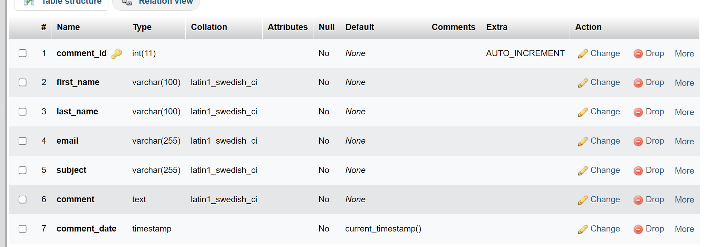

### Order Item table(items within each order)

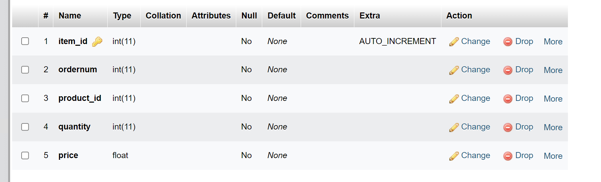Order table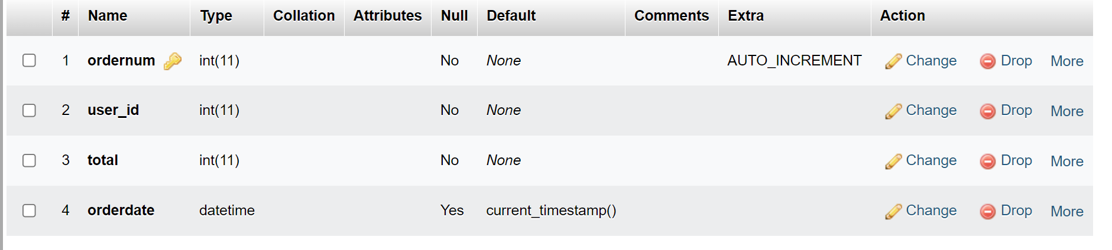User table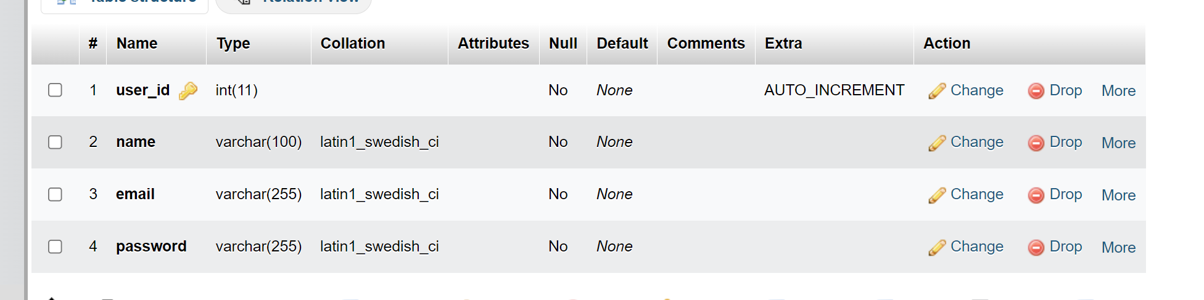Product table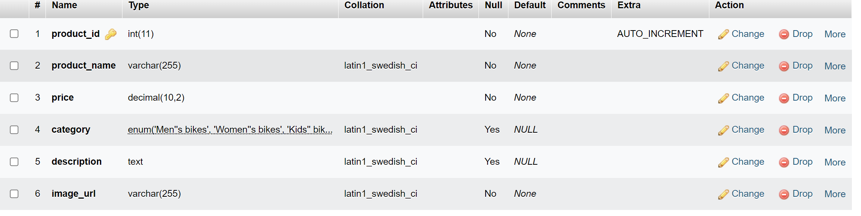

## Database Relation

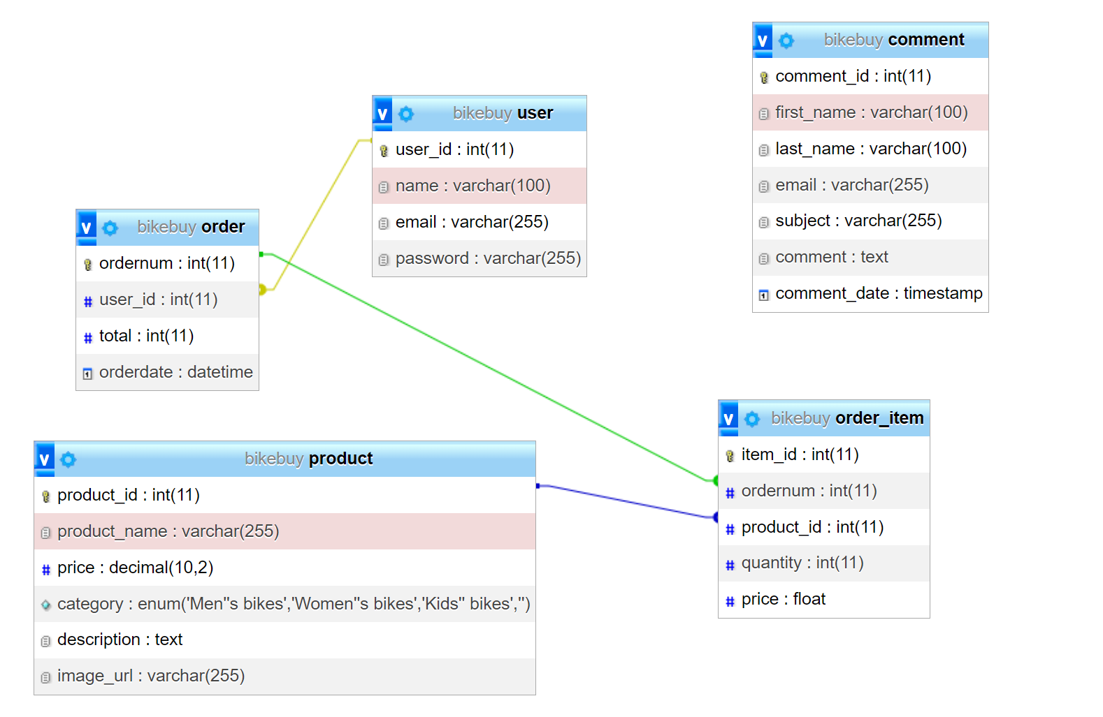

# Features:

Login page:

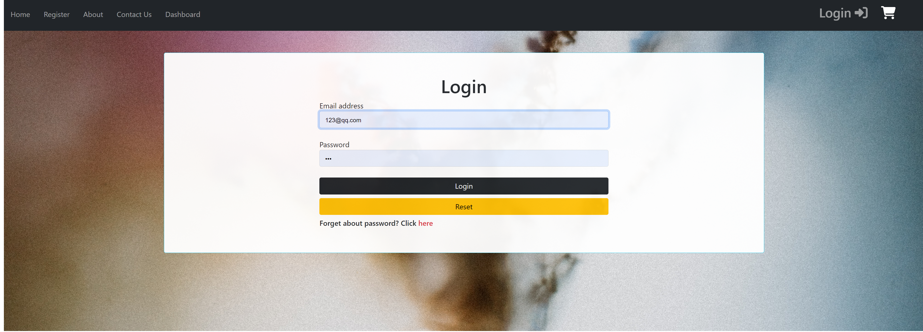

A single login page with basic validation for login purposes.

Message box

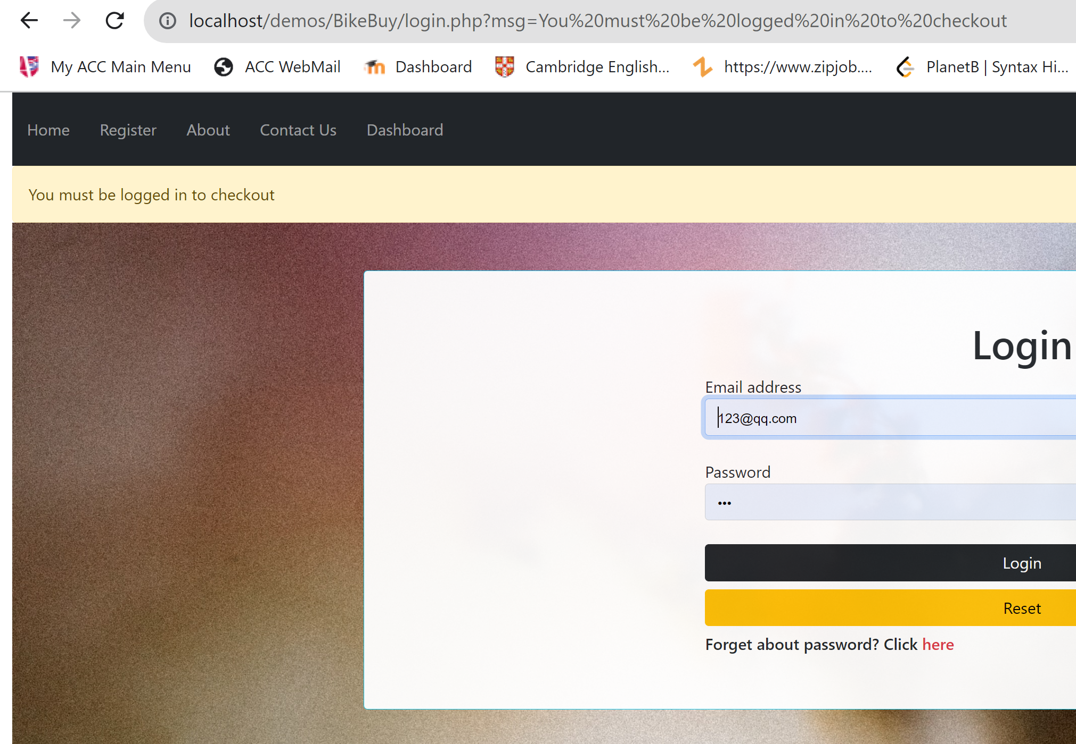

Message will appear at the top of the page(if there’s any) as well as in the URL ‘msg’ dynamic parameter due to the unified message handling mechanism of this project.

Login/Logout and cart at the navigation bar



In the login section, the button will be adjusted to login/logout according to user state

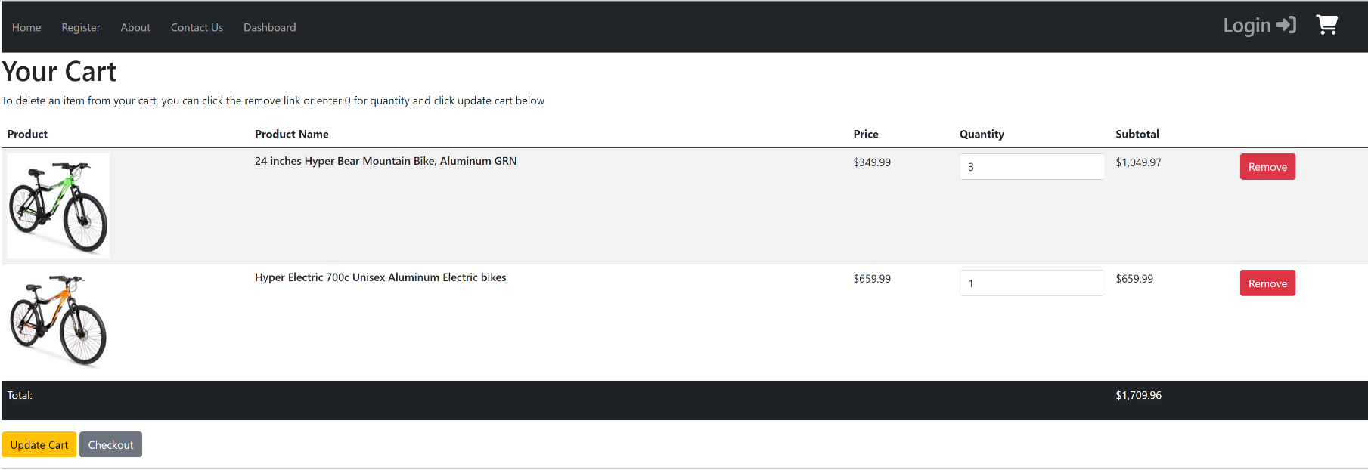Cart

A cart table displaying cart items with editing quantity, remove, and update cart functionality as well as total/subtotal information

# Development Features

MVC architecture

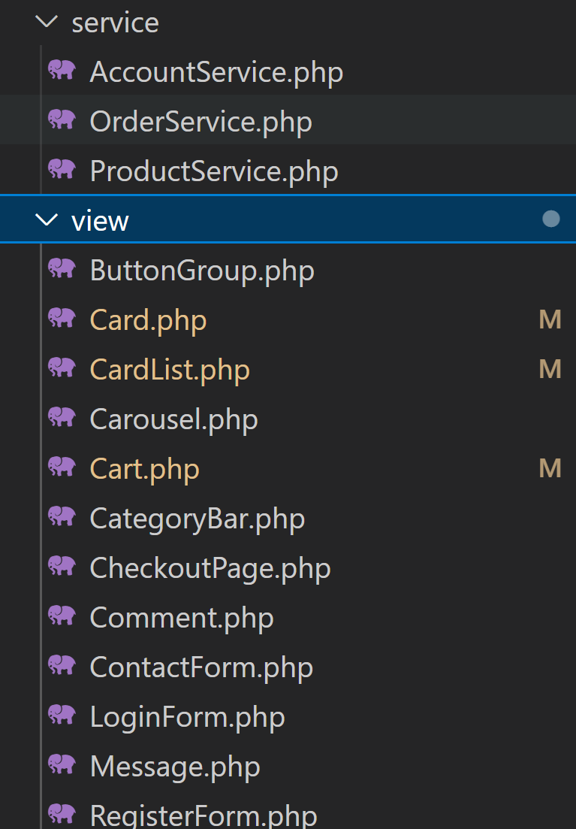

Components on the webpage are rendered by view functions which are reusable and customizable. Meanwhile, all the database operations are entirely executed in the service layer. This is a good practice for decoupling.

The PHP files in the root folder are considered controller files although I didn’t specify explicitly.

Error handling

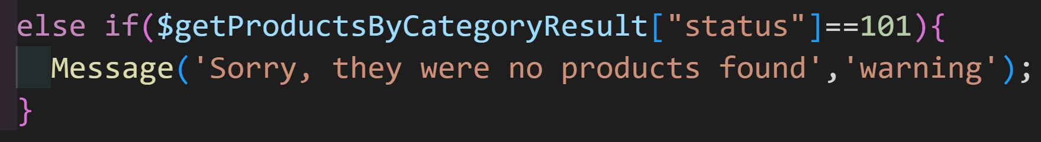

All the error messages could be rendered to the front end and it would show up at the top of the webpage. Each error has a unique error code for it.

**### product service**

-101 : product not be found (empty)

-111: could not get price by product ID

-121: no cart items found

**### Account service**

-201 : Database error: multiple results for the given email and password

-202 : user is not found for the given email and password

-211 : sign up email already exists

**### checkout service**

-301 : checkout error - unknown source

Each service function returns a status code(‘0’ refers to success) and value

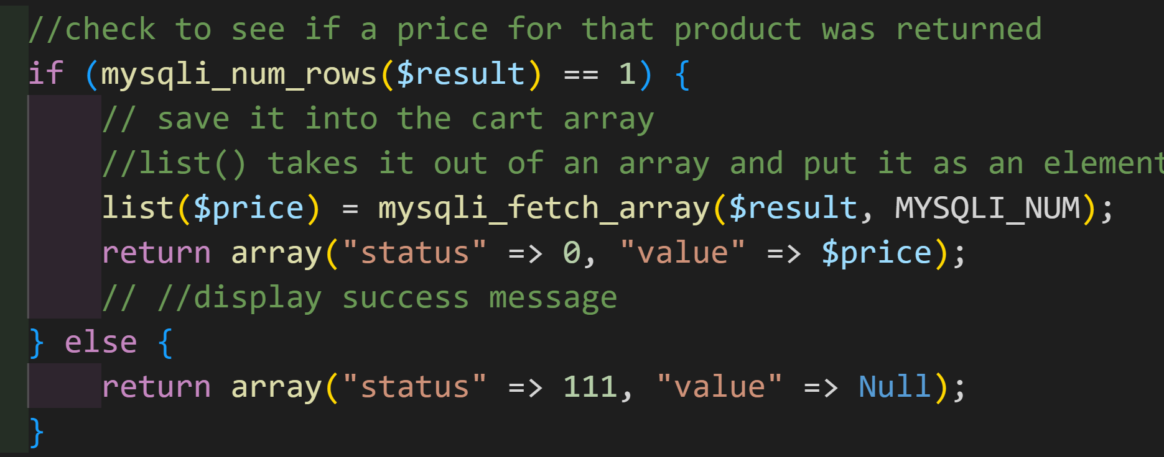

## Conclusion

## what I feel that I did well:

I didn’t use any backend framework. However, my project follows controller-view-service architecture so the components are decoupled(it appeared as if I used some framework). I don’t need to mess up HTML, PHP, and SQL together. My project is easy to maintain once read through it, easy to debug, and scalable.

## what I think I can improve on:

I can use some lightweight frameworks such as vue.js to render dynamic elements on the page, especially the cart page. However, I did not have enough time to do it.

I certainly could refine the details of it and add more features. However, there’s no end to this process.

# Reference:

Login background:

<https://www.pexels.com/photo/plant-on-fire-3357695/>

Checkout background

<https://www.pexels.com/photo/man-facing-road-1248418/>